CS 255 System Design Document Template

This template lays out all the different sections that you need to complete for Project Two. Each section has guidance to prompt your thinking. You will need to continually reference the interview transcript as you work to make sure that you are addressing your client’s needs. There is no required length for the final document. Instead the goal is to complete each section based on what your client’s needs are. Remove this note when you are finished, and replace all bracketed text with the relevant information.

UML Diagrams

UML Use Case Diagram

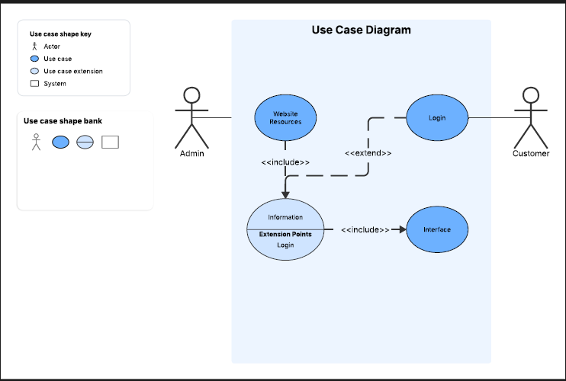

UML Activity Diagrams
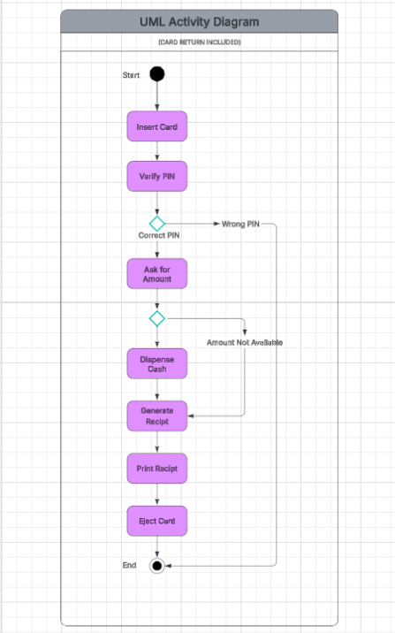
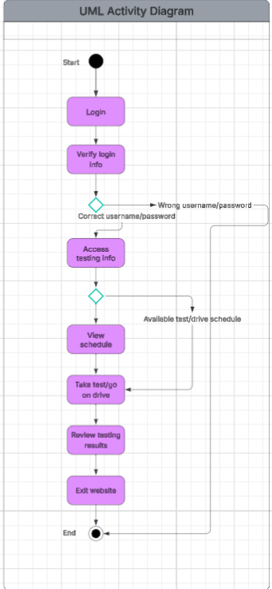

UML Sequence Diagram

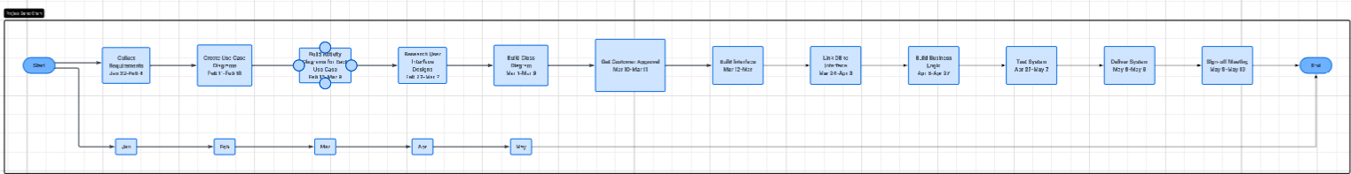

UML Class Diagram

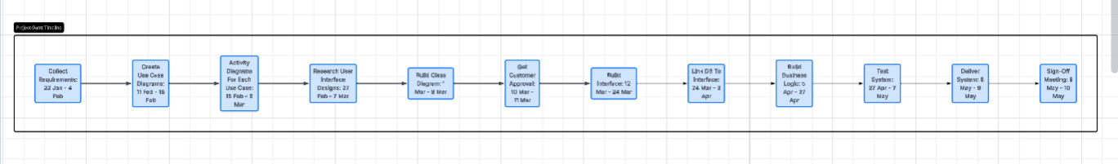

Technical Requirements

The technical requirements needed for the DriverPass system are that it is a web based system, that there are multiple user roles, that it has a secure login and authentication setup, there is a central database, online practice exams, an appointment scheduling system, has real time updates, has backup and data recovery, and system availability. The web based system is important because it allows for users to easily access the system through any device that can access the web. The multiple user roles ensure that everyone accessing the system is able to properly see and use the functions that they need. The secure login and authentication allows for customer information to be protected, schedule changes are managed properly, and instructors/administrators are able to access the appropriate information they need. The central database is for storing all important information such as customer accounts, appointments, practice test scores, and lessons. The online practice exams ensure that customers are prepared for the real thing and also allows for DriverPass to offer more than just driving lessons, as desired. The appointment scheduling system is for ensuring that every instructor and customer is aware of who is working with who. The real time updates are for schedule changes, cancelations, and customer account updates. Backup and data recovery is crucial for protecting customer records and preventing data loss. System availability allows for customers to use study materials or schedule lessons outside of business hours, thus extending the use time of DriverPass beyond a set number of hours.

